MIND STORM SOFTWARE PVT LTD
Hands-On Exercise – ex03.doc
Objective
Multiple Activities in an Android Application
Assumptions
- Development Environment for Android (Java SDK, Eclipse, Android SDK) has been setup successfully.
- You are familiar with using Eclipse.
- Android SDK 2.3.3 is available and Android Virtual Devices are already created.
- Start the Android Virtual Device to save time.
  - Click on Window → Android SDK and AVD Manager.
  - Select an Android 2.3.3 compatible AVD and click on Start
  - Select Scale display to real size and provide a Screen Size (in) as 5 inches or any other appropriate size for your development machine.
Step by Step Instructions
Step 1 – Create the Android Project
- Create a new project. Click on File→New → Android Project
- Enter Project Name as ex03. Click on Next.
- Select the Build Target as Android 2.3.3
- Enter Package Name as com.mindstorm.ex03 .Click on Next.
- In Create Activity, overwrite the default Activity name with the following name : Activity1
- Click on Finish
- (Optional): Verify that the Project runs in your Emulator by Right-click the Project and Run As → Android Application
Step 2 – Create a Second Activity
- Go to Package Explorer in Eclipse for the ex03 project.
- Select the package com.mindstorm.ex03 from within the src directory.
- Right Click and select New → Class
- Enter the name as Activity2
- Enter the Superclass as android.app.Activity
- Click on Finish.
Step 3 – Code the Main Activity
- First we will add some strings to the resources which will be references in the activities. Go to res/values folder and modify strings.xml to contain the following:
<?xml version="1.0" encoding="utf-8"?>
<resources>
<string name="activity1">I am Activity 1</string>
<string name="activity2">I am Activity 2</string>
<string name="app_name">MultipleActivities</string>
<string name="launchActivity2">Launch Activity 2</string>
</resources>
- Define the Layout for Activity1. This will consist of a button which will launch the second activity i.e. Activity2
First, let us delete the main.xml file since we do not need it.
Right-click on res/layout , select New → File and provide the name as activity1.xml. Enter the following content in the activity1.xml file (You can simply copy this):
<?xml version="1.0" encoding="utf-8"?>
<LinearLayout xmlns:android="http://schemas.android.com/apk/res/android"
android:orientation="vertical"
android:layout_width="fill_parent"
android:layout_height="fill_parent"
>
<TextView android:text="@string/activity1" android:gravity="center_horizontal" android:id="@+id/textView1" android:textAppearance="?android:attr/textAppearanceLarge" android:layout_width="fill_parent" android:layout_height="wrap_content"></TextView>
<TextView android:text="Please click button below to sign in first" android:id="@+id/textView2" android:layout_width="wrap_content" android:layout_height="wrap_content"></TextView>
<Button android:layout_height="wrap_content" android:id="@+id/btnLaunchActivity2" android:text="@string/launchActivity2" android:layout_width="match_parent"></Button>
</LinearLayout>

- Go to src → com.mindstorm.ex03 and open Activity1.java file
- Modify the onCreate() method as show below:
public void onCreate(Bundle savedInstanceState) {
super.onCreate(savedInstanceState);
setContentView(R.layout.activity1);

Button btnLaunchActivity2 = (Button) findViewById(R.id.btnLaunchActivity2);
btnLaunchActivity2.setOnClickListener(new OnClickListener() {

@Override
public void onClick(View v) {
Intent i = new Intent(getBaseContext(),Activity2.class);
startActivity(i);
}
});
}

Step 4 – Code the Activity2
- Define the Layout for the Activity2. Go to Right-click on res/layout , select New → File and provide the name as activity2.xml. Enter the following content in the activity2.xml file:
<?xml version="1.0" encoding="utf-8"?>
<LinearLayout xmlns:android="http://schemas.android.com/apk/res/android"
android:orientation="vertical"
android:layout_width="fill_parent"
android:layout_height="fill_parent"
>
<TextView android:text="@string/activity2" android:gravity="center_horizontal" android:id="@+id/textView1" android:textAppearance="?android:attr/textAppearanceLarge" android:layout_width="fill_parent" android:layout_height="wrap_content"></TextView>

<TextView android:text="UserName" android:id="@+id/textView2" android:layout_width="wrap_content" android:layout_height="wrap_content"></TextView>

<EditText android:layout_height="wrap_content" android:id="@+id/editText1" android:layout_width="match_parent">
</EditText>

<TextView android:text="Password" android:id="@+id/textView3" android:layout_width="wrap_content" android:layout_height="wrap_content"></TextView>

<EditText android:layout_height="wrap_content" android:id="@+id/editText2" android:layout_width="match_parent"></EditText>

<Button android:text="Login" android:id="@+id/button1" android:layout_width="fill_parent" android:layout_height="wrap_content"></Button>

</LinearLayout>

- Go to src → com.mindstorm.ex03 and open Activity2.java file
- Modify the source code as shown below for Activity2.java:
package com.mindstorm.ex03;

import android.app.Activity;
import android.os.Bundle;

public class Activity2 extends Activity {
/** Called when the activity is first created. */
@Override
public void onCreate(Bundle savedInstanceState) {
super.onCreate(savedInstanceState);
setContentView(R.layout.activity2);
}
}
- Step 5 – Update the Manifest
We need to ensure that both Activity1 and Activity2 are defined in the AndroidManifest.xml file. Go to AndroidManifest.xml and add the following the following <activity> elements inside of the <application> tag as shown below.
<activity android:name=".Activity1"
android:label="@string/app_name">
<intent-filter>
<action android:name="android.intent.action.MAIN" />
<category android:name="android.intent.category.LAUNCHER" />
</intent-filter>
</activity>
<activity android:name=".Activity2" android:label="@string/app_name"></activity>
Step 6 – Run the Example
- Right Click the Project in Eclipse.
- Select Run As → Android Application
- (Optional): If you have multiple compatible AVDs running, select the correct AVD. In our case it is the 2.3.3 AVD.

You should see the MainActivity screen come up as shown below:
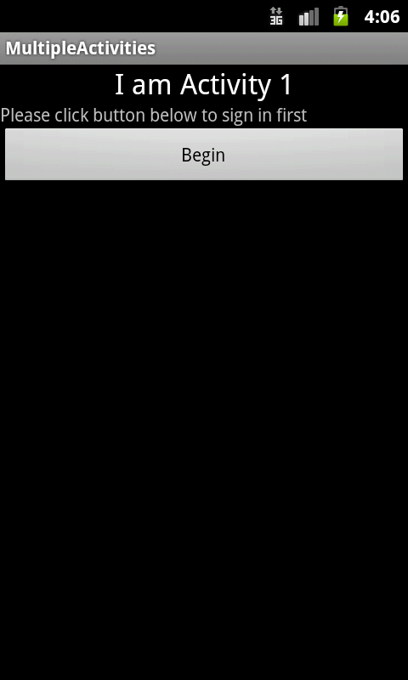

On clicking the Begin button, you should see the second activity screen come up as shown below:
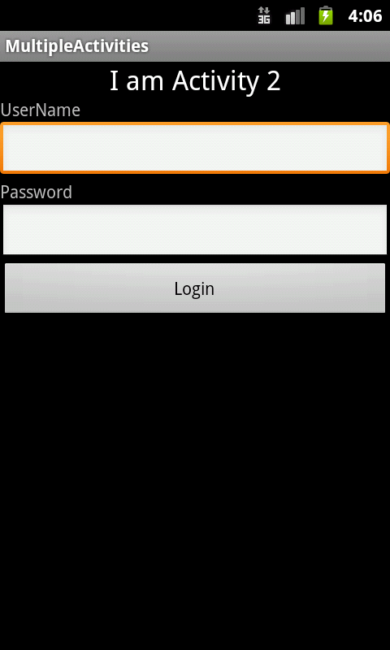
Summary
This hands-on exercise demonstrated how you can have multiple activities (screens) in your Android application. The pattern is simple. Define the Activity class and its layout. Ensure that the Activities are defined in the AndroidManifest.xml file. And launch the activity by explicitly providing the Activity class in the Intent and starting it with startActivity method.

